Final report
template
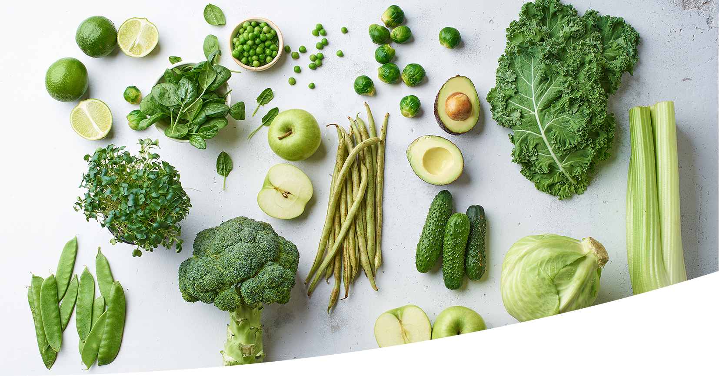

August 2023

Once completed, this report must be submitted in Word format via Hort Innovation’s Delivery Partner Portal.

The body of the report should be limited to a maximum of fifteen pages excluding appendices.

The cover and all text that is included as a prompt for preparing the draft (including this page) must be removed before submission.

Guidance note
This document has been prepared as a template only and has not been adapted for any particular project. The document and its contents will need to be considered against any particular project that it is to be used for and adapted accordingly in consultation with the relevant Hort Innovation Project Manager.

Purpose of final reports
Final reports communicate the outputs and outcomes of Hort Innovation funded projects to key stakeholders such as growers, industry stakeholders, government and others. All final reports will be communicated to industry and other stakeholders by Hort Innovation unless marked as confidential.
The final report should demonstrate how the project has performed against the achievement criteria, outputs and outcomes detailed in the Research Agreement. It should also document any opportunities or issues identified and make recommendations for future RD&E supported by the project findings, and identify any intellectual property, commercialisation and confidentiality issues and developments.
Consider the target audience of the final report and the information that they require to be able to use project outputs, benefit from the project and understand what it achieved.

Photos/images/or other audio-visual material
All photos/images/videos used in reports must also be supplied in high resolution for printing purposes. Separate files may be required for larger-sized images with appropriate usage rights and moral rights waivers.
The following information should be included with all images:
- The name and contact details of the photographer
- The name and contact details of each person appearing in the photograph
- The date on which the photograph was taken
- A detailed description of the image and what it depicts.

Usage rights
Indefinite permission (in the form of a talent release) for use in Hort Innovation publications and reporting should be obtained from any person appearing in any image and provided to Hort Innovation.
All personal information (as defined in the Privacy Act 1988 (Cth)) should be provided in aggregated form and de-identified with underlying consents in place.

Confidentiality
Confidential material should be clearly marked confidential in yellow highlight so it can be removed before making the balance of the report publicly available. If this is not possible, a public final report should be provided along with the confidential final report.
[DELETE THE COVER AND THIS PAGE BEFORE SUBMISSION]

Final report

Project title:

< Insert project title
line 2 if required >

Project leader:
<Insert project leader name>

Delivery partner:
<Insert full organisation name – no acronyms>

Report author/s:
<Insert author name>

Project code:
<Insert project code – e.g., AB20000>

Date:
<Day, Month and Year e.g., 10 April 2021>

Report sensitivity:
Does the report have any of the following sensitivities?
Commercialisation/IP considerations: No Yes
Intended for journal publication: No Yes
Embargo date: No Yes – Date: <Day, Month and Year e.g., 10 April 2021>
Please detail the reason for the embargo:
Confidentiality: No Yes (whole report) Yes (sections of report are confidential)
If sections of the report are confidential, list them here:

Disclaimer:
Horticulture Innovation Australia Limited (Hort Innovation) makes no representations and expressly disclaims all warranties (to the extent permitted by law) about the accuracy, completeness, or currency of information in this final report.
Users of this final report should take independent action to confirm any information in this final report before relying on that information in any way.
Reliance on any information provided by Hort Innovation is entirely at your own risk. Hort Innovation is not (to the extent permitted by law) responsible for, and will not be liable for, any loss, damage, claim, expense, cost (including legal costs) or other liability arising in any way (including from Hort Innovation or any other person’s negligence or otherwise) from your use or non-use of the final report or from reliance on information contained in the final report or that Hort Innovation provides to you by any other means.

Funding statement:
Retain the appropriate funding statement (no heading) below. If your project’s funding structure does not fit the two options below, please see the Hort Innovation Publication’s Guide or consult with the Hort Innovation Communications Team by emailing communications@horticulture.com.au. Delete the remaining funding statements and this instruction.
Levy funds – R&D projects
This project has been funded by Hort Innovation, using the <insert industry> research and development levy and contributions from the Australian Government. Hort Innovation is the grower-owned, not-for-profit research and development corporation for Australian horticulture.
Hort Frontiers – R&D projects
<Insert project name> is funded by the Hort Frontiers <insert fund name>, part of the Hort Frontiers strategic partnership initiative developed by Hort Innovation, with co-investment from <insert list of contributing partners> and contributions from the Australian Government.

Publishing details:
ISBN <Hort Innovation to add>
Published and distributed by: Horticulture Innovation Australia Limited
ABN 71 602100149
Level 7
141 Walker Street
North Sydney NSW 2060
Telephone: (02) 8295 2300
www.horticulture.com.au
© Copyright 202X Horticulture Innovation Australia Limited

Contents
Public summary 4
Technical summary 4
Keywords 5
Introduction 6
Methodology 7
Results and discussion 8
Outputs 9
Outcomes 10
Monitoring and evaluation 11
Recommendations 12
Refereed scientific publications 13
References 14
Intellectual property 15
Acknowledgements 16
Appendices 17
[UPDATE THE CONTENT TABLE BEFORE SUBMISSION]

Public summary
< This summary should provide a project overview stripped of all confidential information that is suitable for public dissemination and should be no more than 500 words in length. This summary will also be required to be uploaded into the Delivery Partner Portal. This will be the information Hort Innovation primarily uses to communicate about the project and what it achieved and produced for industry with stakeholders including growers, industry participants, government and others. It is imperative that it is written in clear, everyday language – avoid jargon.
The public summary should answer the following questions:
- Why the work was done (state the problem and motivation for undertaking the work)
- How the work was done (what approach did you take and what was the extent of your work)
- What industry impacts and benefit/s will arise from the work (what were the results and implications of your work)
- What new information or resources are available and where they can be accessed?
For further information, refer to Attachment A3: Final report guide >

Technical summary
< This section should be completed for confidential and technical projects only. Otherwise it should be deleted. Provide an at-a-glance overview of the project in full. For further information, refer to Attachment A3: Final report guide >

Keywords
<Insert keywords, for example: lettuce; Integrated Pest Management; thrips. For more information, refer to Attachment A3: Final report guide >

Introduction
< Provide the background to the project, its rationale (why the project was undertaken) and the significance for industry. For more information, refer to Attachment A3: Final report guide >

Methodology
< Outline how the project was undertaken. This will include the work performed such as experiments, field trials, technology development and extension/training events. If the methodology included the use of data/information from other/previous projects or linkage to extension/communication activities in other projects, then this should be detailed. The high-level scientific methodology only should be included in the body of the final report, with the detail (necessary for the methodology to be repeated) provided as an appendix. For more information, refer to Attachment A3: Final report guide >

Photos/images/other audio-visual material
< Refer to Attachment A3: Final report guide or the guidance note at the start of this template >

Results and discussion
< Provide results of the work undertaken including applicable tables, graphs and figures generated through the project. All data sets and/or databases should be supplied as appendices to the final report (and marked confidential as appropriate). The discussion should outline what the results mean for use and uptake by horticultural businesses or other industry stakeholders or for future/related research projects. Detailed scientific information (e.g. tables and figures) should be provided in appendices. Consider the target audience of the final report. For more information, refer to refer to Attachment A3: Final report guide >

Photos/images/other audio-visual material
< Refer to Attachment A3: Final report guide or the guidance note at the start of this template >

Outputs
< Project outputs are the tangible products or services (deliverables) that are produced from the project activities. List tangible project outputs delivered with appropriate description and detail.
A summary of the project’s outputs should be completed using the table below, using monitoring data collected to provide evidence of outputs as per the project’s M&E Plan (where applicable). Examples of the outputs must be supplied as an appendix and uploaded into the Delivery Partner Portal (where appropriate), and if the output is digital, a link to the output is also required.
Provide a detailed list of extension activities conducted over the project life and any associated links to other projects and documentation.
Table X. Output summary
Output | Description | Detail
< List the output (e.g. best practice guide, study tour, new variety, technology or growing protocols )> | < Describe and define the output, including the intended audience. For example, for publication type outputs describe the content, number and reach > | < Include a brief explanation of how and where the output was made available (or next steps required to make it available), and evidence of engagement by the intended audience, e.g. survey data of usefulness, adoption rates, commercialisation agreements. Include a hyperlink for publicly available outputs >

Photos/images/other audio-visual material
< Refer to Attachment A3: Final report guide or the guidance note at the start of this template >

Outcomes
< Detail the intermediate and end-of-project outcomes and how these support relevant Fund outcomes (as per industry Strategic Investment Plan(ies) or Hort Frontiers Strategy). Outcomes are the desired result of the project and represent the project’s unique contribution to the relevant Fund outcome(s), strategy(ies) and Key Performance Indicator(s). For grant projects (or projects with external funding sources) the linkage to grant outcomes should also be included where appropriate.
A summary of the project’s outcomes should be completed using the table below, supported with monitoring data collected to provide evidence of outcomes as per the project’s M&E Plan. Where possible provide a statement of costs and benefits achieved in delivery of the project. For more information, refer to Attachment A3: Final report guide >
Table X. Outcome summary
Outcome | Alignment to fund outcome, strategy and KPI | Description | Evidence
< List the outcome (e.g. knowledge, awareness, practice change, commercialisation, availability of new knowledge for next phase project) > | < Align to the relevant Fund outcome, strategy and KPI > | < Describe and define the outcome in terms of how it was realised by the target stakeholder group(s). Explain how the outcome is relevant at the Fund level > | < What forms of evidence were collected to identify and understand the outcome (e.g. survey, observation, feedback) >

Monitoring and evaluation
< Discuss overall project performance, answering the Key Evaluation Questions (KEQs) that were identified within the project’s M&E Plan (if relevant). Areas for continuous improvement should be identified and discussed where relevant. For more information, refer to Attachment A3: Final report guide >
Table X. Key Evaluation Questions
Key Evaluation Question | Project performance | Continuous improvement opportunities
< Refer to the M&E Plan > | < Identify aspects of project performance that address the Key Evaluation Questions > | < List opportunities for improvement and future development >

Recommendations
< List the recommendations and next steps resulting from the project. This section should include clear and concise recommendations for relevant stakeholders such as growers, researchers, Hort Innovation and other audiences:
• Practical application of the project findings
• Possibilities of future RD&E that directly flow from the work undertaken and its results
• Development and adoption activities that would ensure full value from the project’s findings for industry. >

Refereed scientific publications
< Provide a list of all refereed scientific publications published during the reporting period and associated links that can be attributed or partly attributed to the project. Use the below formatting guide (and delete guide when done). For more advice, refer to Attachment A3: Final report guide >

Journal article
Orange, V., Apple, G.S., Banana, L.F., 2013. The nutritional profile of fruit varieties in Australia. Journal of Horticultural Research 163, 51–59.

Whole book
Lettuce, I., Tomato, B.R., 2014. The Base Elements of a Salad (second edition). Vegetable Publishing, Melbourne.

Chapter in a book or paper in conference proceedings
Broccoli, G., Capsicum, R.G., 2013. Growing fruits and vegetables. In: Peach, J.S., Avocado, R.D. (Eds.), Introduction to Australian Horticulture. Horticulture Publishing, Sydney, pp. 281–304.

References
< Provide a list of publications and information sources referred to in the final report. If there are no references or information sources, delete this section >

Intellectual property
< Enter ‘No project IP or commercialisation to report’ if there are none to report.
Project IP: Include a detailed summary of all Project Intellectual Property (IP) using Hort Innovation’s IP Register that is available on the Delivery Partner Portal. The IP Register must be signed and dated.
Provide details of any developments or issues (including in relation to any royalties, license fees, patents, trademarks, copyright materials/data and domains/URLs, plant breeder’s rights and include any usage right restrictions that have arisen during the project and details of the management of project IP. Full details should be provided in the IP Register. >

Acknowledgements
< Provide any acknowledgements or delete section if not applicable>

Appendices
< Please note that all appendices are published with the final report. If an appendix includes information that should not be published, such as commercially or institutionally-sensitive material such as sensitive meeting minutes, provide it to Hort Innovation separately and clearly mark it confidential. Appendices should include outputs and key project documents such as an IP Register. >

